DRUGS: PORTRAIT OF A KILLER
DRUGS IN MOVIES AND IN REAL LIFE
We’ve all heard about illegal/illicit drugs either from the movies, TV, or everyday life. But, do you know what kind of impact drugs have on the individual? Have you seen the effects first hand?


COCAINE:

Cocaine is stimulant in powder form, formed from the coca bush in South America. This drug began gaining popularity in the 50’s and has been a highly sought drug since. You’ve probably seen cocaine depicted in many movies (such as Blow, The Doors, and Jackie Brown) as a white powder inhaled through the nose. The physical affects of cocaine include depression, paranoia, hallucinations, cardiac or respiratory failure, elevated blood pressure, and insomnia just to name a few.


Marijuana:

Marijuana is an extremely popular drug and equally deadly. It is portrayed in many movies such as Half Baked, in which the characters are constantly high, or in a state of euphoria. Although Marijuana is sometimes used for medicinal purposes, it has been widely abused. Either smoked through a bong or a special cigarette (many times known as a joint), marijuana causes personality problems, loss of memory, lung cancer, brain damage and fertility problems.
Heroin:
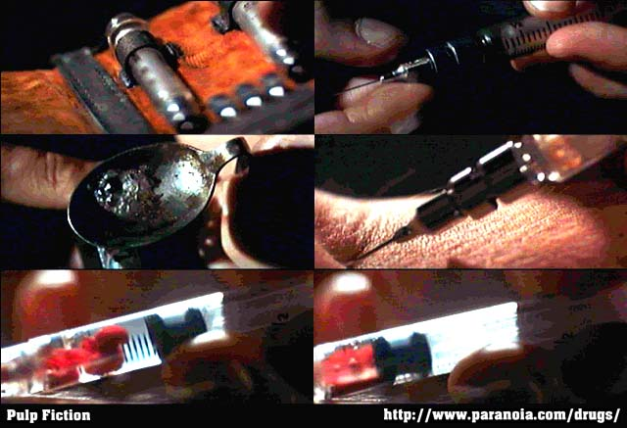
Made from morphine, unlike marijuana it has no medical purposes in the US. Heroin is extremely illegal and has been portrayed in movies such as Pulp Fiction and Trainspotting in which heroin is injected into the arm through a syringe. Heroin depresses the central nervous system and can cause comas, death, and birth defects for pregnant women.

STEROIDS:
This drug has become increasingly popular among teen athletes; anabolic steroids, to be specific. Anabolic steroids are at times used as medicine to build muscles for patients with chronic diseases. But, the drug has been abused by illegally abused by athletes to enhance performance (such as in A View To A Kill and Swimfan). What these athletes don’t realize though, is that the initial results of steroids are gain in muscle mass and physical performance but the long term results include liver damage, heart disease, stroke, decrease in sperm and testicle size for men, breast shrinkage and facial hair for women, and severe mood swings.

THESE ARE JUST A FEW EXAMPLES OF THE ILLEGAL DRUGS YOU SEE ON TV AND IN THE MOVIES. I HOPE THAT THIS BROCHURE HAS GIVEN YOU A LITTLE INSIGHT INTO THE CONSEQUENCES OF ILLEGAL DRUGS AND WILL DISCOURAGE YOU FROM USING THEM IN THE FUTURE.

