COULEE-HARTLINE MISSION STATEMENT

PREPARING STUDENTS FOR SUCCESS IN A CHANGING WORLD

by

* Fostering a secure and caring environment
* Advocating life-long learning
* Challenging students to maximize their potential
* Promoting responsibility
* Building positive relationships
* Valuing individual differences

SET THE SCENE FOR SUCCESS

Common Expectations

At Coulee City Elementary/Middle School, it is expected that each student will:
- Be Respectful
- Be Responsible
- Work hard to do his/her best

Classroom Expectations

Students will:
- Be on time and come to class prepared
- Be on-task without disrupting others
- Have necessary supplies when entering class
- Be attentive and cooperative in every class
- Request and make up work missed during any absence from school
- Complete assignments on time
- Follow procedures and rules established by each teacher
- Know and follow the rules printed in the student handbook

Campus Expectations

Students will refrain from:
- Creating disruptive noises
- Improper displays of affection
- Displaying disrespectful behavior
- Pushing or shoving
- Littering
- Running in building
- Name calling -"putting down" others
- Wearing hats in building/wearing bandanas
- Chewing gum
- Using offensive or vulgar language

Nine Characteristics of High Performing Schools

- All Staff have a clear vision and purpose for the school.
Staff has participated in creating a common vision.

- All Staff have high expectations for all students.
All staff believe that all students can meet high standards.

- Effective leadership exists in instructional areas.
Many staff assume a leadership role.

- Staff plan and work extensively with one another.
Staff communicate frequently about academic matters.

- Curriculum and instruction are aligned with state standards.
Instruction is often provided beyond normal hours.

- Student progress is analyzed on regular basis.
More instruction is provided to students who need help.

- Professional development is focused in areas of most need.
Extensive and ongoing professional development is provided.

- Students feel safe in a healthy learning environment.
Students feel respected and connected with teachers and staff.

- Parents and the community have extensive links to the school.
Outside resources are obtained to help
GOALS

Following are the goals as revised during the summer and fall of 2005. These goals will always be a “work in progress” and subject to change as some are achieved and other needs of the school are identified.

CURRICULUM & ACADEMIC ACHIEVEMENT

GOAL: Students at Coulee City School will continue to improve their performance on all WASL tests.

OBJECTIVE: No later than 2014, all students in grades four and seven will meet the minimum WASL standards on the math test.

OBJECTIVE: No later than 2014, all students in grades four and seven will meet the minimum WASL standards on the reading tests.

OBJECTIVE: No later than 2014, all students in grades four and seven will meet the minimum WASL standards on the writing tests.

OBJECTIVE: No later than 2014, all students in grades five and eight will meet the minimum WASL standards on the science tests.

OBJECTIVE: No later than 2008-09, all students in fifth and eighth grades will participate in yearly social studies Classroom Based Assessments.

OBJECTIVE: By the 2008-09 school year, the school shall adopt and implement a comprehensive health and fitness curriculum consistent with the EALRs.

PROFESSIONAL DEVELOPMENT & PLANNING

GOAL: Time for professional development and district staff collaboration will be provided.

OBJECTIVE: Each school year, three half-days for staff development and/or SIP planning/implementation will be added to the district calendar.

OBJECTIVE: Teachers will meet at the beginning of each school year and at least once each trimester to discuss Title I, special education, LAP and curriculum issues and concerns.
COMMUNICATIONS

GOAL: The school will improve communications with parents.

OBJECTIVE: At the beginning of each school year, parents will be given an opportunity to communicate suggestions or concerns for the coming year, and invited to join school decision-making committees.

OBJECTIVE: At the beginning of each school year, teachers will explain the grade level expectations to parents at the fall open house.

OBJECTIVE: Teachers will continue to communicate each child’s progress to parents least four times through the school year.

SCHOOL IMPROVEMENT AND THE ELIMINATION OF BULLYING, INTIMIDATION & HARASSMENT

GOAL: Incidents of bullying and harassment at school will be reduced each year until they are eliminated.

OBJECTIVE: During the 2005-06 school year, a bullying survey will be given to students in grades 3-8.

A. The survey results will provide a new base line to measure improvement in the school climate.

B. The counselor, with the assistance of the principal and the faculty, will review the results of the survey
and determine a plan of action to reduce the incidents of bulling, harassment and intimidation.

C. District policy prohibits bullying, harassment and intimidation, and those who violate the rules will face
the consequences as outlined in the student handbooks.

ENRICHMENT PROGRAMS

GOAL: The after-school enrichment program will be expanded.

OBJECTIVE: At a minimum, 2 or 3 before/during/after school extra curricular programs that provide a wide range of opportunities for meaningful involvement for both boys and girls will be provided each trimester.
Top of Form
2004-05 WASL State Results
Grade Level
Reading | Math | Writing | Science
4th Grade | 79.5% | 60.8% | 57.7%
5th Grade |  |  |  | 35.6%
7th Grade | 69.0% | 50.8% | 61.2%
8th Grade |  |  |  | 36.4%
10th Grade | 72.9% | 47.5% | 65.2% | 35.8%

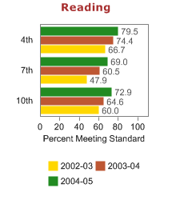 | 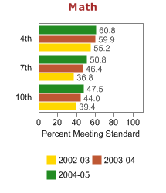
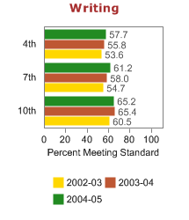 | 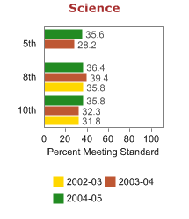

Bottom of Form

Top of Form

Top of Form
2004-05 Coulee City WASL Results
Grade Level
Reading | Math | Writing | Science
7th Grade | 57.1% | 71.4% | 35.7%
8th Grade |  |  |  | 36.8%

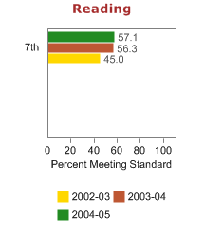 | 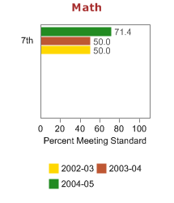
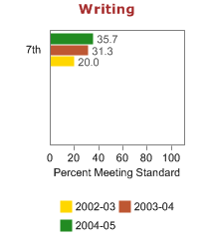 | 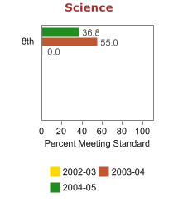

Bottom of Form

Top of Form
2004-05 Coulee City WASL Results
Grade Level
Reading | Math | Writing | Science
4th Grade | 100.0% | 93.8% | 68.8%

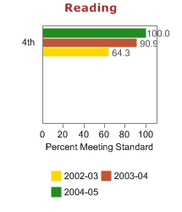 | 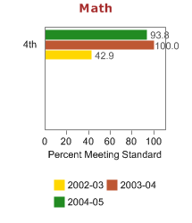
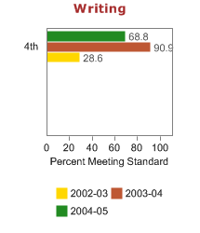

Bottom of Form

